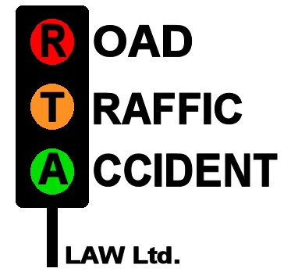

St Bede’s Chambers
Albert Road
Jarrow
Tyne & Wear
NE32 5JB
Tel: 0191 4203630
Fax: 0191 4203605

ROAD TRAFFIC ACCIDENT LAW LTD
Specialists in Non-Fault Accidents
& Personal Injury Claims
Fax: 0191 420 3605

From:…………………………………………………………………………………
Tel:…………………………………………………………………………………...

Customers Name:………………………………………………………………….…
Address:……………………………………………………………………………...
Tel. No. Home……………………………… Work:….…………………………….

Please Circle As Appropriate.
PERSONAL INJURY: YES / NO

Immediate Hire Write Off Driveable Comp TPFT Credit Repair

NOTES:-…………………………………………………………………………………
……………………………………………………………………………………………
……………………………………………………………………………………………

WE CAN HELP – FAX NOW TO
RTA LAW
0191 – 420 3605

